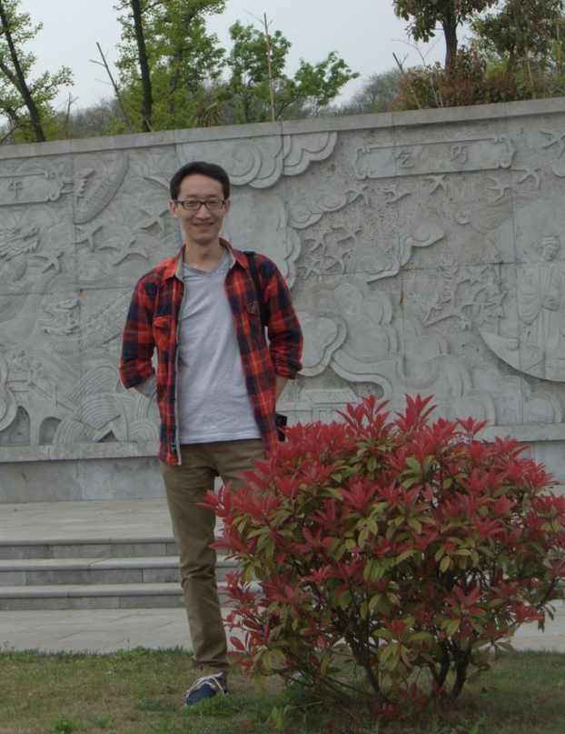
Shengjun Tan, PhD
Email: clamp131@gmail.com
Address: Institute of Zoology, Chinese Academy of Sciences, Datun Road, Chaoyang District, Beijing 100101

I am now an assistant investigator in Yong’s lab. The research I am working on is the origin and evolution of new genes within species. We want to figure out the molecular mechanism of new gene burst, the fate of these new-born genes and the evolution forces behind it. It is a very interesting and also changeling program.
EDUCATION BACKGROUND
Ph.D. (expected May 2012) in Life Science Department
Nanjing University (Nanjing, China), 2007 - 2012
Dissertation: Codon and codon pair usage bias in living organisms
B.E. in Life Science Department
Nanjing University (Nanjing, China), 2003 - 2006
Dissertation: Avoidance of long mononucleotide repeats in codon pair usage

RESEARCH EXPERIENCE
Graduate student with Dr. Dacheng Tian and Dr. Jianqun Chen in Nanjing University
- Project: high-throughput cloning resistance genes from rice species
Developed a new way to quickly and effectively clone functional genes resisting blast disease in rice. I am responsible for transforming R genes into rice genomes in this project.
- Thesis Research: investigating the universal trend of codon and amino acid evolution
An investigation in the codon and codon-pair usage and amino acid changes using bioinformatics

PUBLICATIONS
- Tan S, Zhong Y, Hou H, Yang S, Tian D: Variation of presence/absence genes among Arabidopsis populations BMC Evolutionary Biology 2012, 12:86
- Tan S, Wang D, Ding J, Tian D, Zhang X, Yang S: Adaptive evolution of Xa21 homologs in Gramineae Genetica 2011, 139(11): 1465-1475.
- Wu Y, Yuan H, Tan S, Chen JQ, Tian D, Yang H: Increased complexity of gene structure and base composition in vertebrates. J Genet Genomics 2011, 38(7):297-305
- Wang J, Tan S, Zhang L, Li P, Tian D: Co-Variation Among Major Classes of LRR-Encoding Genes in Two Pairs of Plant Species. Journal of molecular evolution 2011, 72(5-6):498-509.
- Gu T, Tan S, Gou X, Araki H, Tian D: Avoidance of long mononucleotide repeats in codon pair usage.Genetics 2010, 186(3):1077-1084.
INTERSTS
Table tennis, watching movies, funning stories.

